**CSE3502-Information Security Management**

**LAB 9 – BurpSuite Brute Force Attack**

**Name:** Eshan Das

**Registration Number:** 19BCE1575

**DATE:** 5th April, 2022

**Proxy Connection configured**

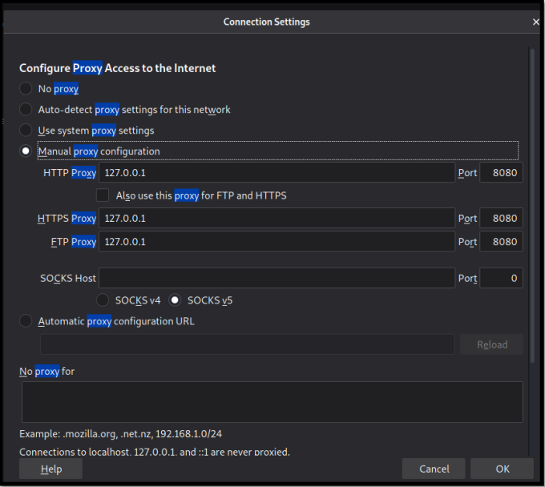

**Switch on the intercept**

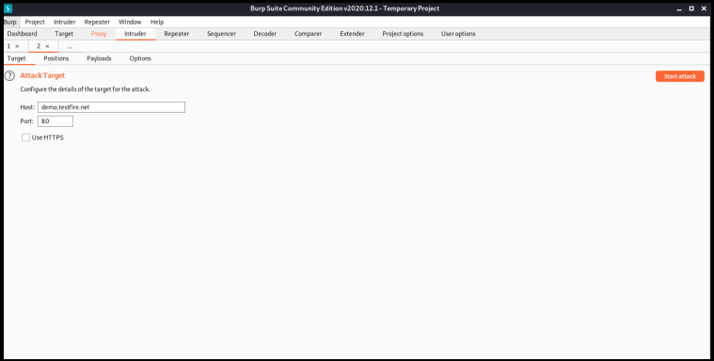

**4 Attack Types**

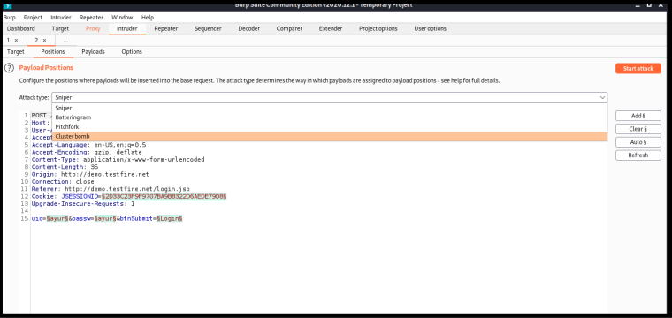

**Open demo site for login and try out all attacks**

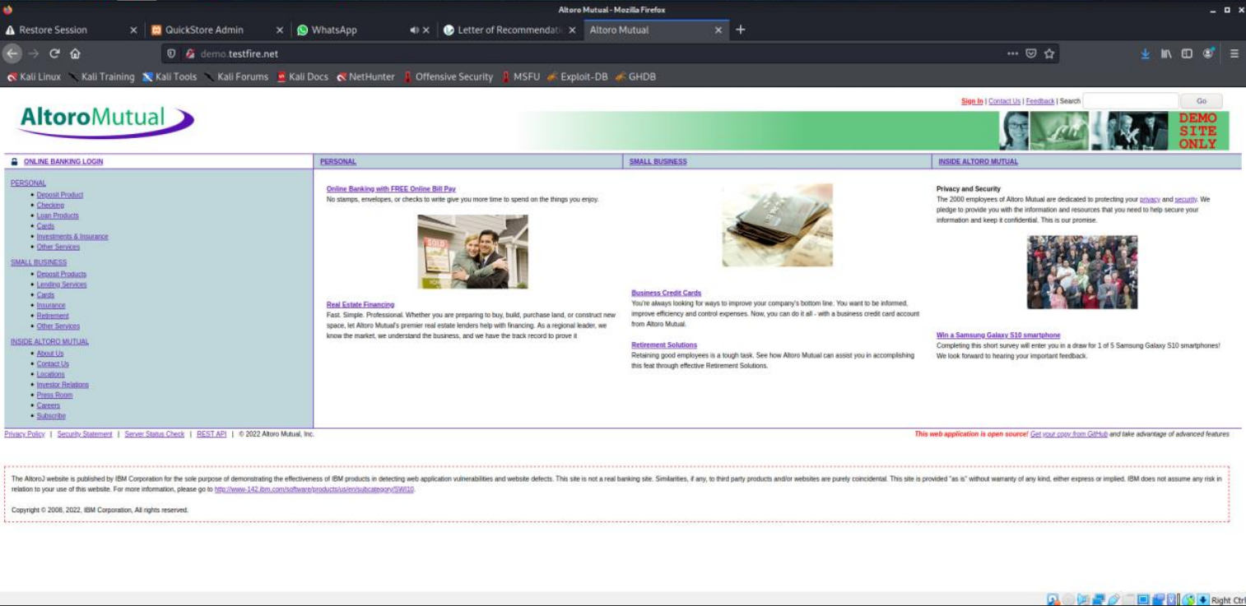

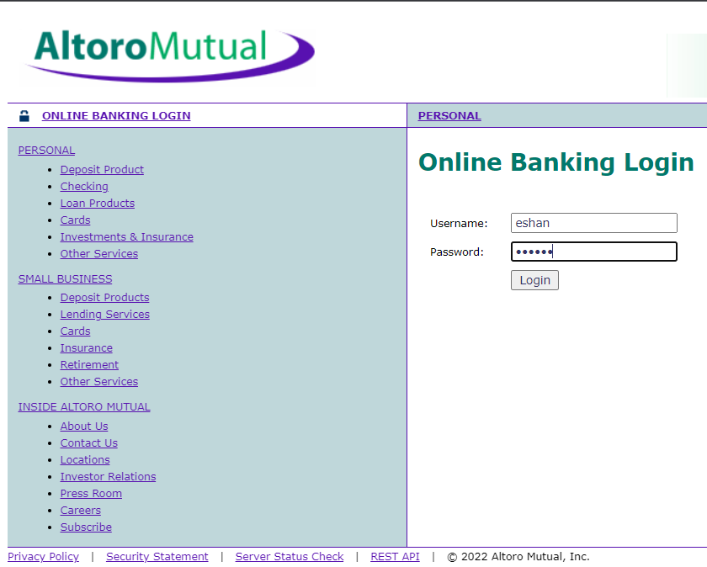

**Pitchfork**

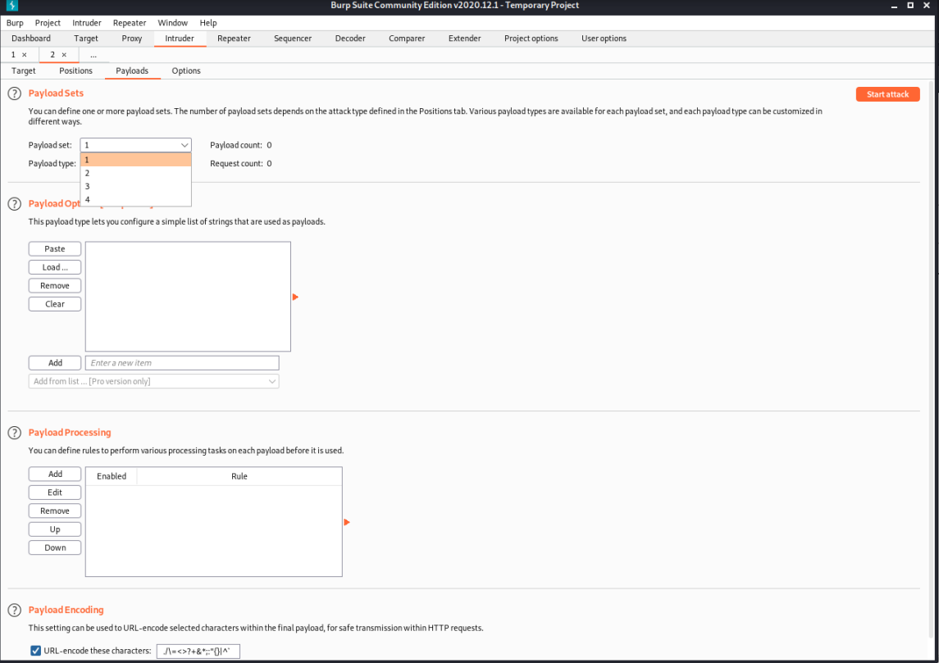

**Cluster Bomb**

**Payload**

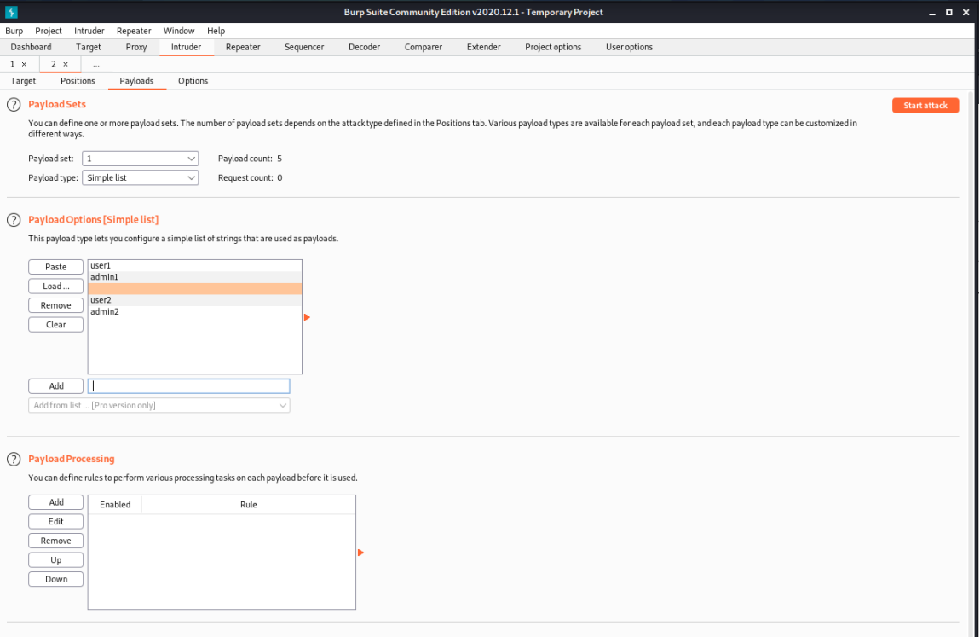

**For sniper attack**

**Start attack**

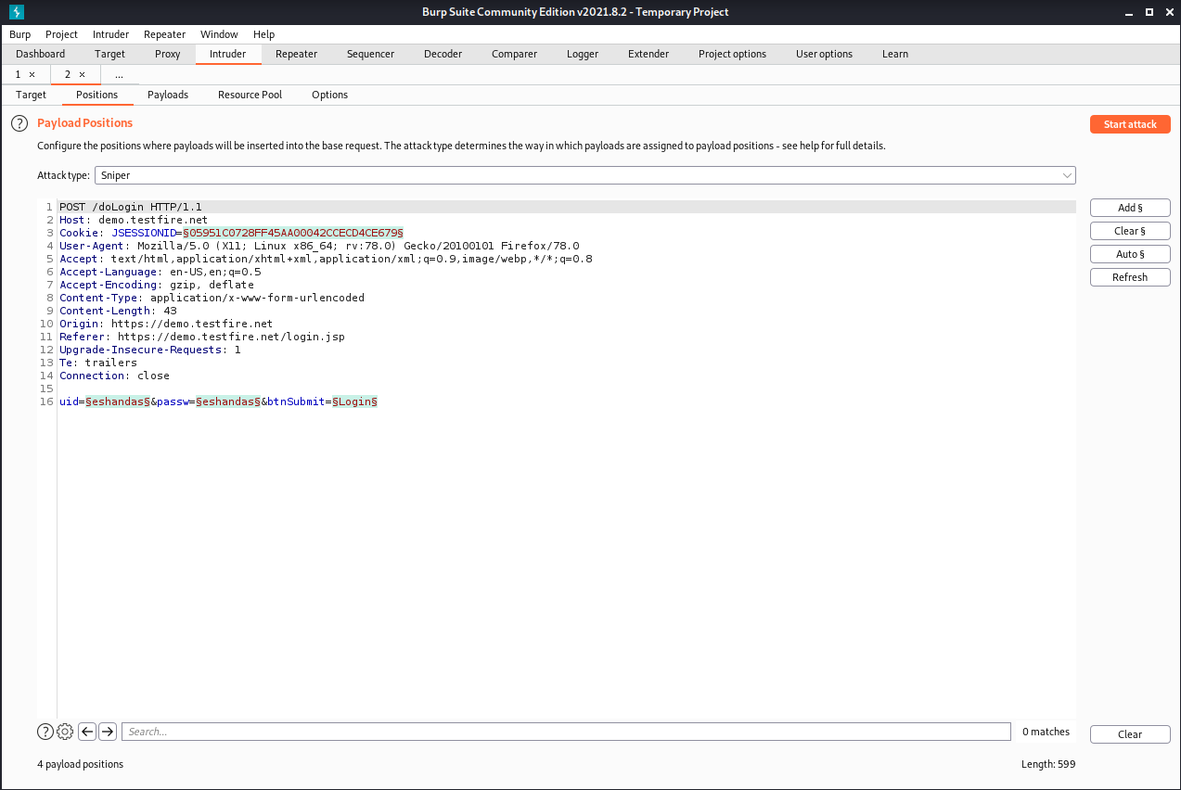

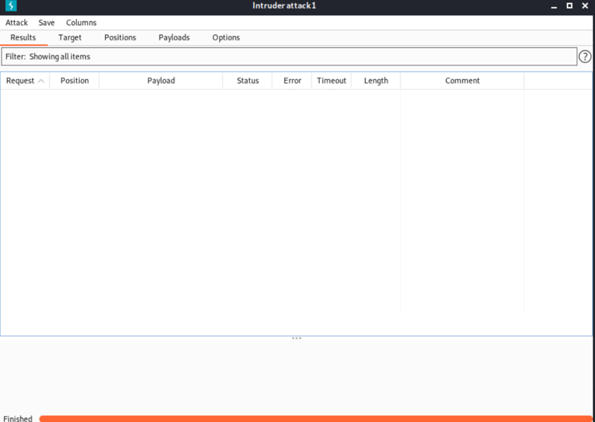

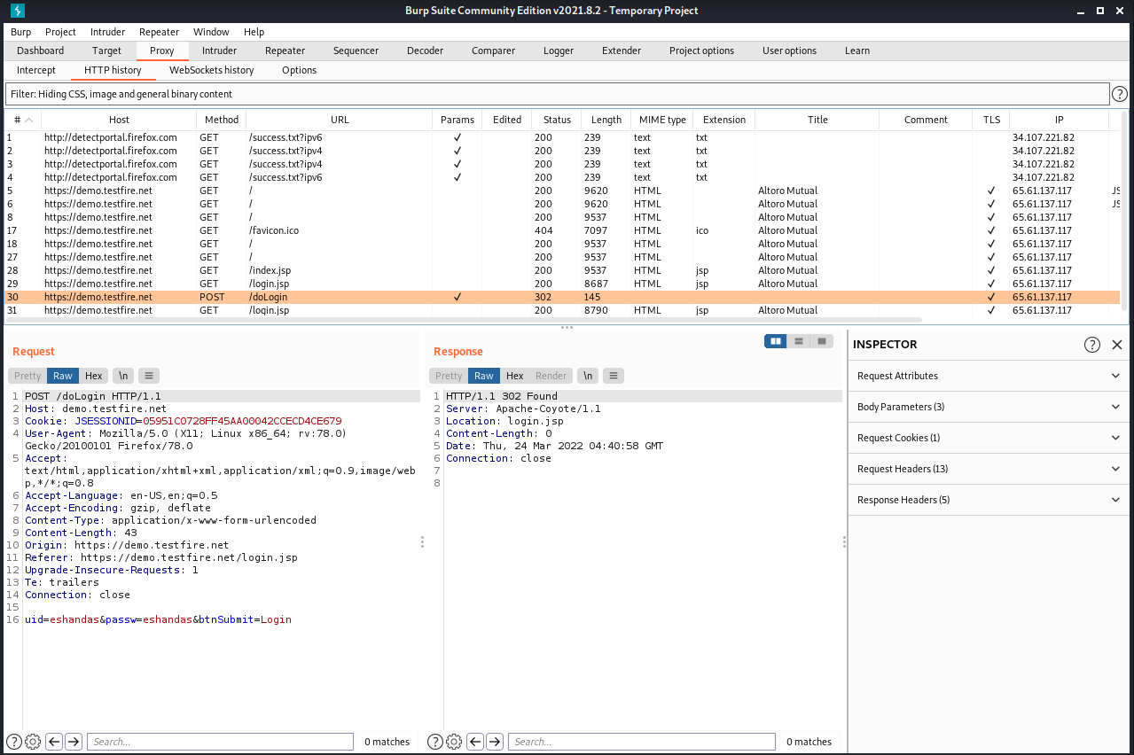

**Demo website 4 attacks and Own website 4 attacks**

**Battering ram attack**

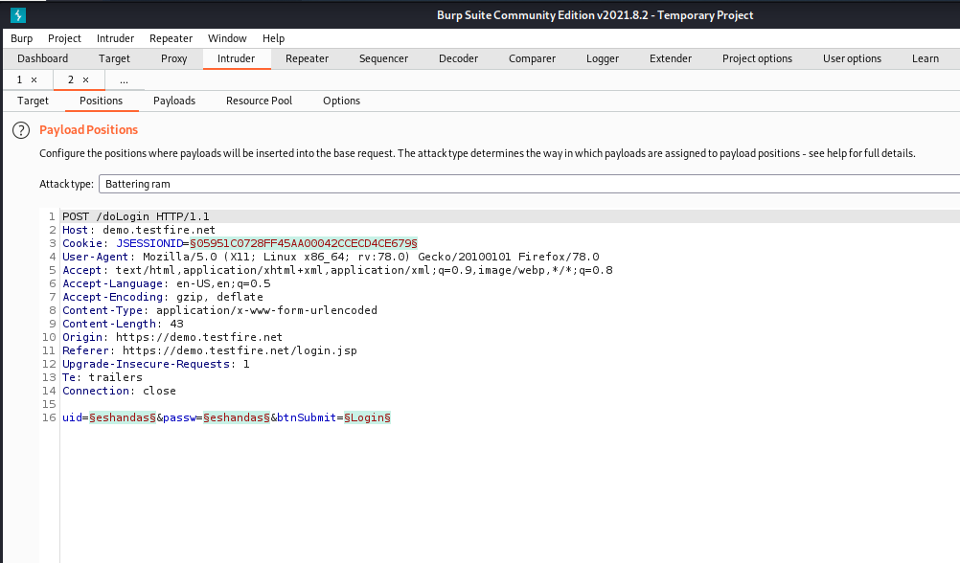

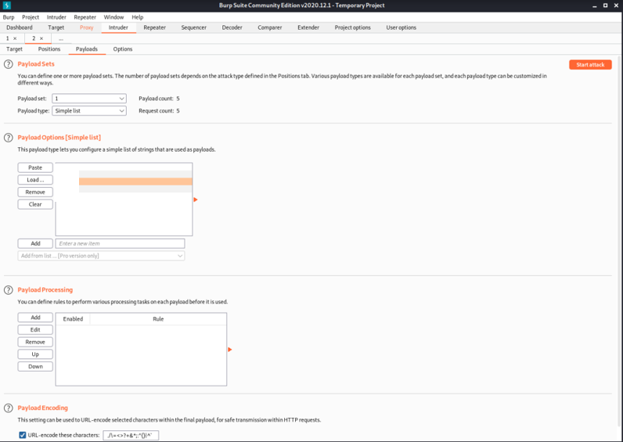

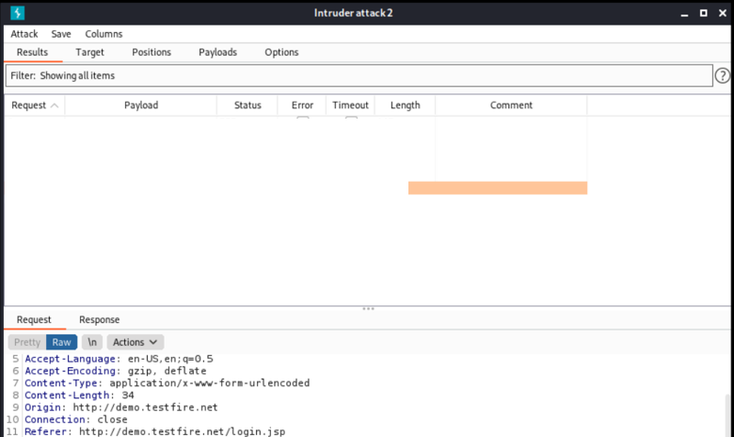

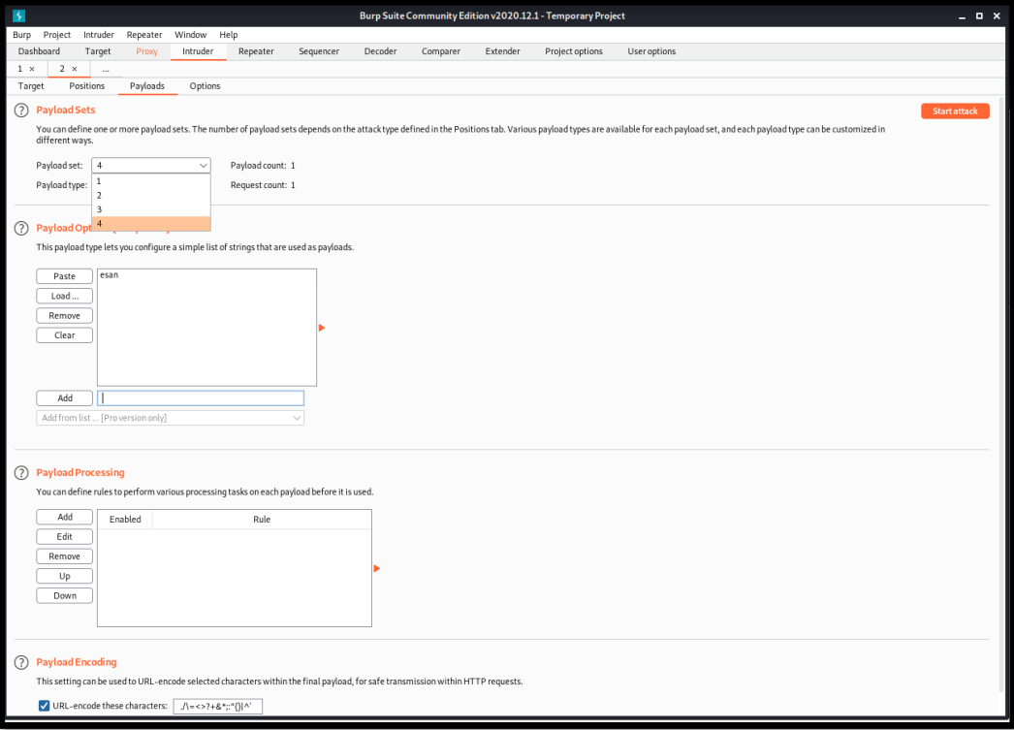

**Pitchfork attack ()**

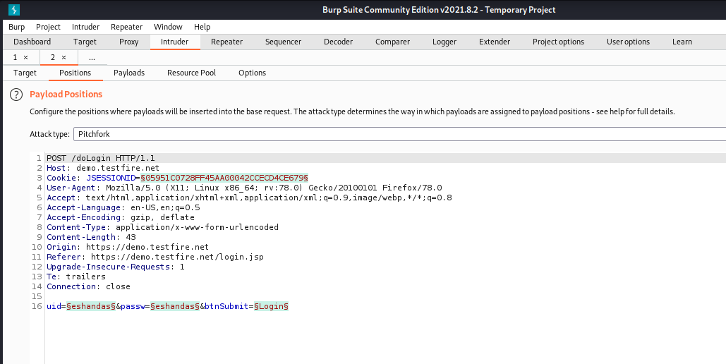

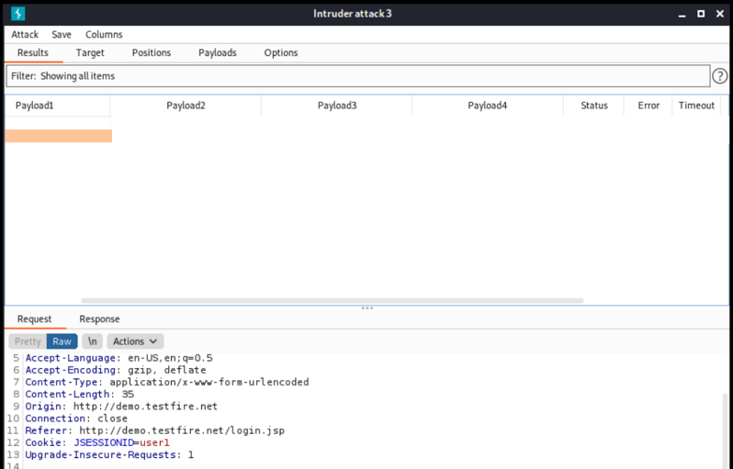

**Clustering Bomb Attack**

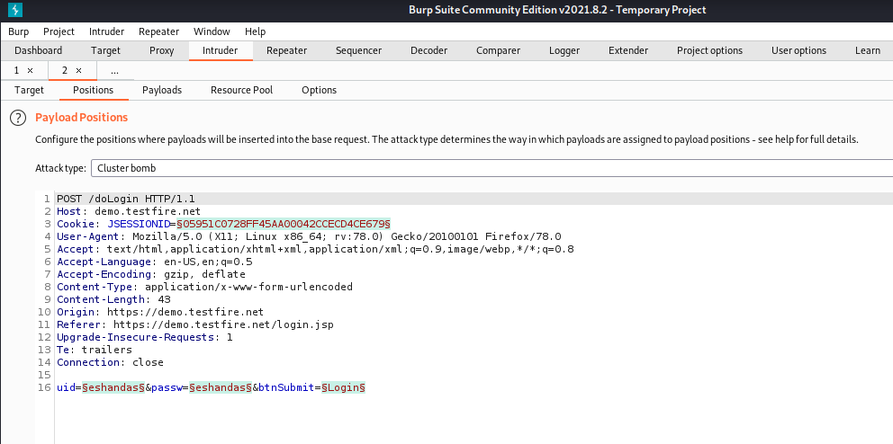

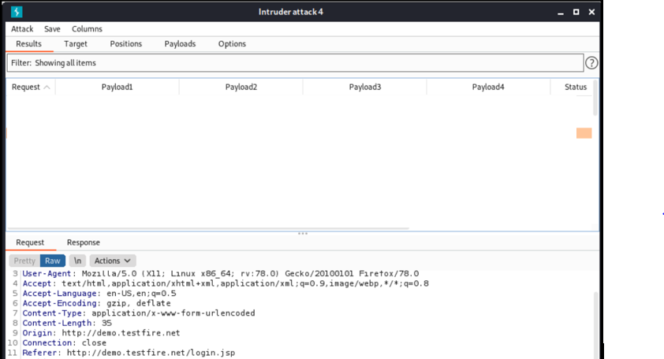

**Similarly creating own website page and trying all 4 attacks mentioned above.**

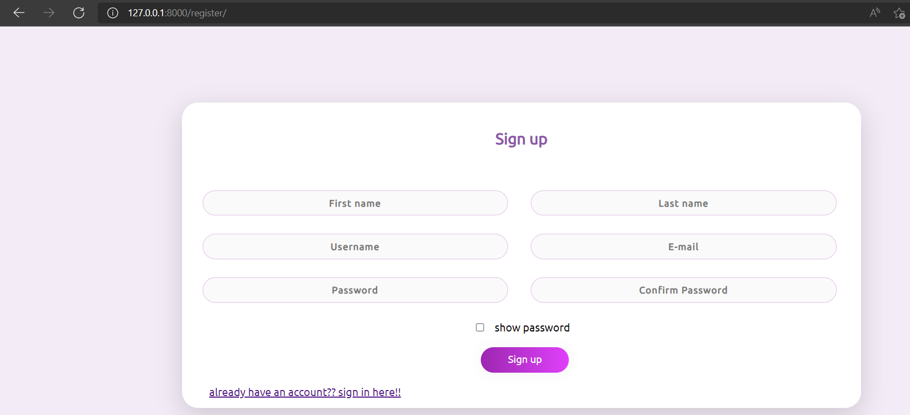

**Login the website Quickstore Admin Portal (Self-made website)**

**Go to burpsuite then choose Intruder and then select target**

Again set target host as 127.0.0.1

Port :80

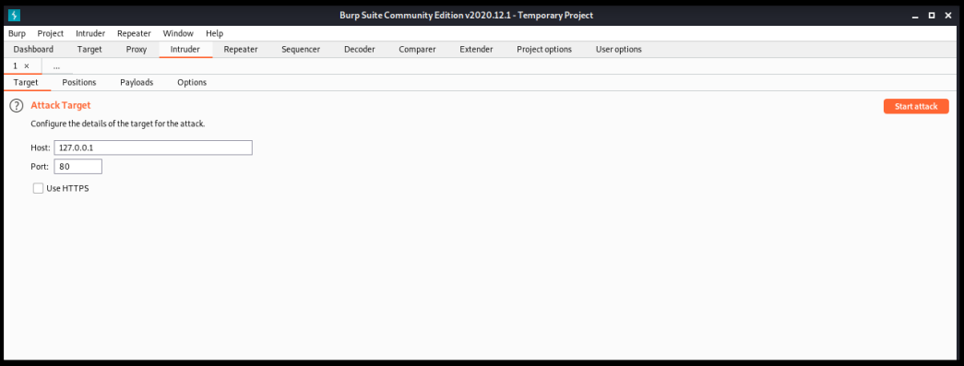

**Go to payloads section and payloads as per attack type**

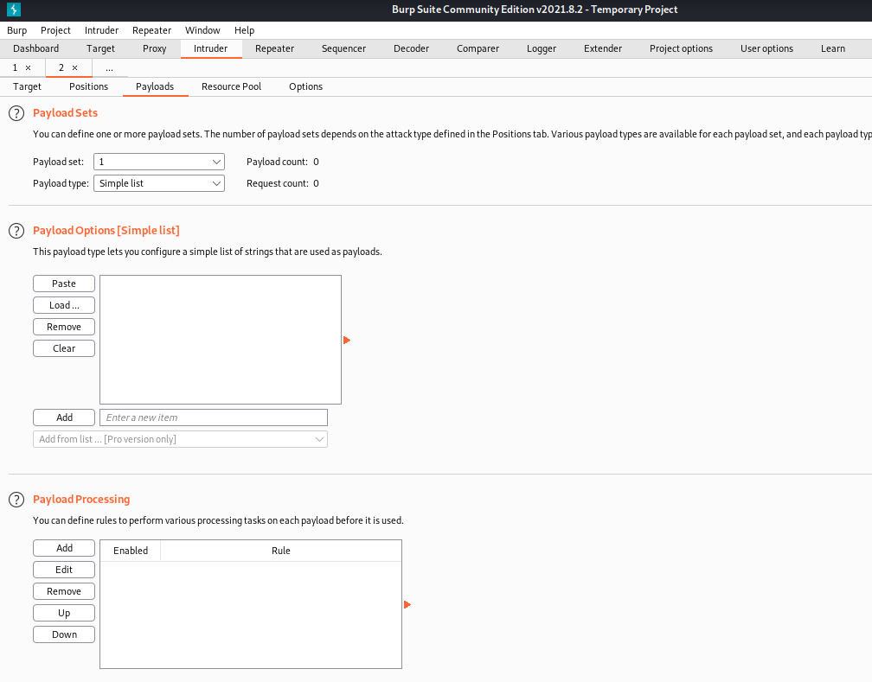

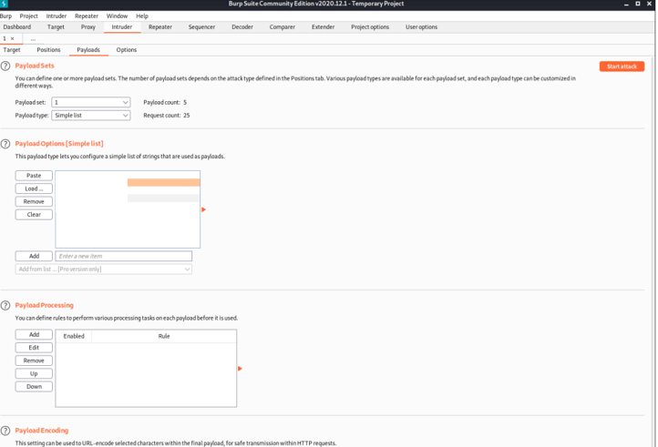

**Set attack type: sniper**

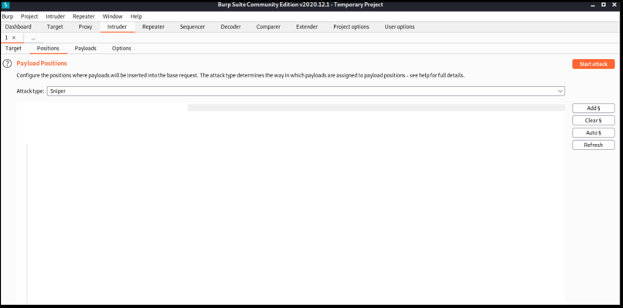

**Start Attack**

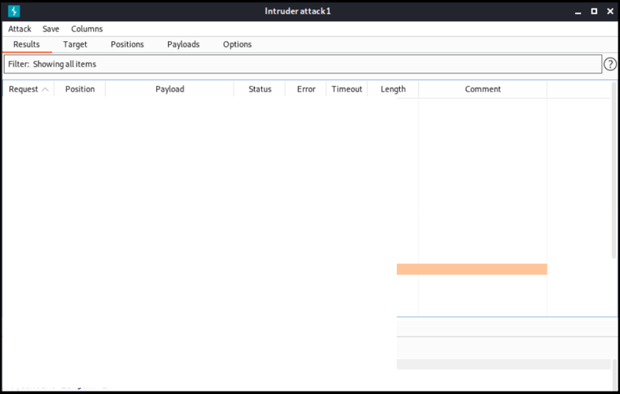

**Battering ram attack**

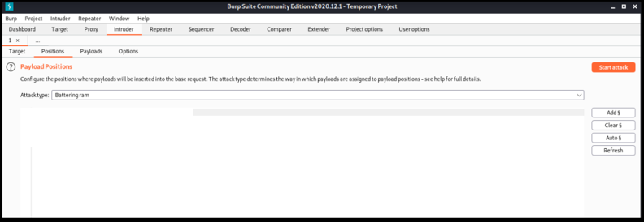

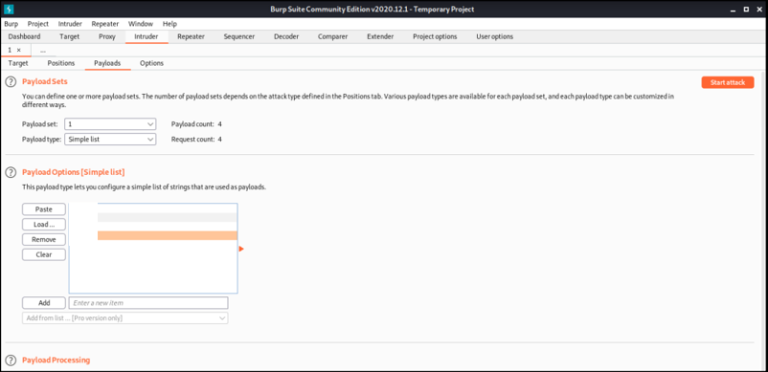

**Pitchfork attack**

Provide different values for payloads and click on start attack

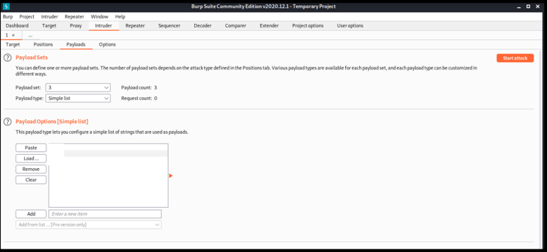

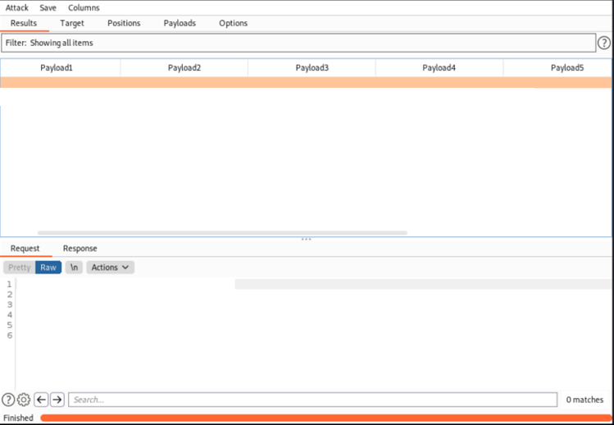

**Clustering Bomb attack**

Provide different values for payloads and click on start attack

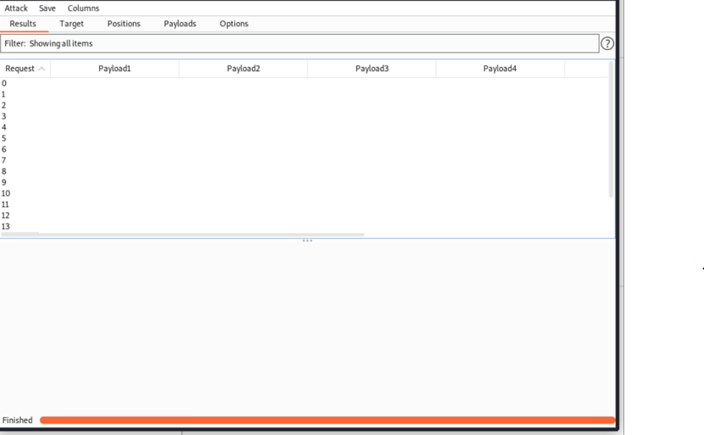

**Result:** All the attacks were successfully executed on a demo website and a self- made demo website used for login.